**Resource availability of pulse-blooming crops impacts plant-pollinator community stability**

Olivia Shaffer1, Salena Helmreich1, Liesl Oeller1, David W. Crowder1

1 Department of Entomology, Washington State University, Pullman, WA, 99164, USA

**Abstract**

The availability of floral resources across landscapes influences the stability and composition of wild pollinator communities. Globally, many habitats have been converted to agricultural systems that provide little to no pollen or nectar resources. However, agricultural systems can also include crops like canola that provide massive pulses of resources. As a mass blooming crop, canola has been shown to be a significant food source for bees. This study samples bee communities 3 times per year (pre, peak, and post-canola bloom) at 10 sites along a gradient of canola landscape composition to measure within-year responses in stability and diversity. The variations in overall abundance and percentage dissimilarity index (PDI) of bee taxa over time were used as a measure of community stability. While bee richness, diversity, and abundance were maintained regardless of canola percentage, temporal stability marginally increased in response to canola. However, PDI, representing the stability of genera composition overall, was not significantly affected. This could be due to a high proportion of solitary bees with short flight ranges, making these communities largely resistant to the destabilizing effects of pulse blooms at the landscape level. This study underlines that understanding how these pulses may affect bee communities in conjunction with community composition is a key priority for pollinator ecology and conservation.

**Introduction**

Wild bees provide critical pollination services to natural and managed ecosystems (Winfree 2010; Kennedy et al. 2013; St. Clair et al. 2022). However, low diversity in agricultural landscapes compounded with the increasing acreage converted to non-blooming crops leads to declines in pollinator abundance and diversity (Kremen et al. 2002; Koh et al. 2016; Rollin et al., 2019; St. Clair et al. 2022) and in turn plant-pollinator community instability (Kennedy et al. 2013; Huang et al. 2021). Unstable plant-pollinator communities are more susceptible to external disturbances and extinction events (Tilman 1999; Cottingham et al. 2001; Worm and Duffy 2003; Huang et al. 2021). In addition to the impact of long-term landscape conversion on plant-pollinator community stability, there may also be an effect of short-term changes of resource availability seen in pulse-blooming crops (Gardner et al. 2021). There are many studies focused on local and landscape effects on wild bees in agroecosystems, but few of these look at the impact of short-term blooming crops on plant-pollinator community stability.

While millions of acres of natural habitat are converted to crops that provide no nectar resources to pollinators like soybean, corn, cotton and cereals (Koh et al. 2016; Rollin et al. 2019; St. Clair et al. 2021), agricultural systems can also include mass-flowering crops like field beans (*Vicia faba*) and canola (*Brassica napus*) that provide massive pulses of resources (Holzschuh et al. 2013; Westphal et al. 2003; Gardner et al. 2021). However, the short-term bloom of these crops rarely spans the entire active period of local bees, causing resource variability within a season (Riedinger et al. 2015; Westphal et al. 2009; Gardner et al. 2021) and leading to phenological differences in land cover between agriculture and natural areas (Leong et al. 2015). This agricultural system negatively impacts wild bee communities twofold; both replacing native ecosystems and shifting the temporal windows in which floral resources are available may translate to lower stability of these plant-pollinator communities.

One factor that may mitigate the impact of a pulse-bloom event on bee community stability is the size of local natural areas and their proximity to the crop bloom. Studies on landscape-level effects on bee communities and pollination services have mainly focused on the importance of natural habitat surrounding cropping systems; these natural areas may provide critical floral resources and nesting sites that improve plant-pollinator community stability (Westrich 1996; Williams and Kremen 2007; Huang et al. 2021). Kremen et al. (2004) found higher pollination service stability with increasing semi-natural habitat. Another study by Pywell et al. (2015) found a higher proportion of natural habitat led to greater pollination services, measured by crop yields. Increasing boundary features adjacent to pulse-blooming crops led directly to more stable pollination services by wild bees as well as higher populations of solitary bees (Gardner et al. 2021). However, large agricultural areas with coincidental blooms may attract bees away from natural habitats, leading to lower diversity and stability. While we know that larger natural areas near crop fields can increase bee community and service stability, the inverse impact of pulse-blooming crops on diversity and stability of plant-pollinator interactions is yet unknown.

Here we assessed plant-pollinator community stability in natural areas near canola, a common pulse-blooming crop used in dryland agriculture rotations. We completed bee and plant biodiversity studies in natural areas before, during, and after nearby canola bloom. We then analyzed landscape context, and calculated abundance, species richness, Shannon diversity, temporal stability, and PDI (percentage dissimilarity index) for both bee and plant communities. Finally, we assessed the impact of canola proximity on those stability indicators. We showed the importance of bee and floral diversity in mitigating the impacts of pulse-blooming crops on plant-pollinator community stability.

**Materials and Methods**

***Study System***

In the Palouse region of Eastern Washington, USA, canola (*Brassica napus*) is widely used as a rotational crop, typically with wheat, and aids in weed control and nutrient cycling (Esser and Hennings 2012). Canola is a pulse-blooming crop that flowers between 2-3 weeks per year (Canola Council of Canada), and the bright yellow flowers and mass blooms are attractive to a diverse group of bees (Olsson et al. 2021). In the last ten years, canola production in Washington has expanded from 51,000 to 130,000 acres (USDA National Agricultural Statistics Service 2017), causing fragmentation of the native Palouse prairie ecosystem, historically dominated by perennial bunchgrasses, shrubs, and wildflowers (Weddell 2001; Looney et al. 2012). As of 2012, only 0.1% of the native plant community within this landscape remained and is now adjacent to agricultural fields (Looney 2012). However, a diverse community of bees is found within the Palouse prairie; recent surveys found 174 species in prairie remnants (Rhoades et al. 2017). As canola offers a novel and abundant food resource for bees, the risk for destabilization of these remnant communities must be assessed to understand the long-term stability of pollinator communities in this region.

***Study Sites***

This study was conducted in 10 sites throughout Eastern Washington in the summer of 2022 (Fig.1.1). Sites were wildflower patches (semi-natural to natural habitat) selected along a gradient of canola field percentage within a 2 km buffer and distance to canola fields. Canola field percentage within 2 km ranged from approximately 0-43%. Sites ranged from approximately 11-8100 m in distance from canola fields. All canola fields were spring canola varieties.

***Sampling Periods***

We conducted bee and plant biodiversity surveys at 3 separate periods during the 2022 spring canola growing season. These periods represent pre-, peak-, and post-canola bloom to capture the effects of the pulse bloom on bee communities. The canola bloom stage was determined by the approximate canola field bloom percentage. These periods are defined as a)Pre-bloom: June 2 – June 15, 2022, before approximately 20% of the canola field reached bloom; b) Peak-bloom: June 28 – July 8, 2022, when approximately 80% of the canola field bloomed; c) Post-bloom: July 19 – August 2, 2022, when approximately 30% of blooms remained and the majority of the canola field is in seed production.

***Bee Biodiversity Survey***

At each site, we placed four 50 m × 7 m walking transects. Transects were placed during the first sampling period in areas with flowers visibly blooming and remained in place throughout the survey. We collected bees by continuously sweep-netting or 10 minutes along both 50 m sides of each walking transect. Each 5 m interval was sampled for 1 minute to ensure even sampling. This resulted in a total of 20 minutes of sampling per transect. Once the first side of a transect was sampled we placed the bees caught into a gallon Ziplock bag and placed samples on dry ice. We repeated the process for the opposite side of the transect. Bee samples were stored at -20°C and identified to genus using the Michener 2007 bee genera key and The Bee Genera of Eastern Canada key (Michener 2007; Packer et al. 2007).

***Plant Biodiversity Survey***

We conducted plant biodiversity surveys for each site during each of the three sampling periods. At each site, the same transects as the bee surveys were used. Plant surveys were typically conducted on the same days as bee sampling, but if not the same day, plant surveys were always done within a week of bee sampling. We placed a 1m2 quadrat at the same meter marker within each transect. Placement was changed between periods to avoid re-sampling the same flowers. We recorded all plants in bloom within each quadrat. Unknown plant species were identified using *iNaturalist* (3.2.6) (iNaturalist 2022). For plants requiring further identification, samples were collected and later pressed for identification using Washington State University herbarium resources.

***Measuring Landscape Context***

Background landscape context was evaluated using USGA Cropland Data Layers (CDL) from 2022 (USDA National Agricultural Statistics Service 2022). Landscape types were placed into 10 categories: *Non-flowering Agriculture, Barren, Development, Tree Fruit Crops, Forest and Tree Crops, Wetland/Open Water, Pasture, Canola,* and *Other Flowering Agriculture*. We calculated the percentage of each of the 10 landscape categories within a 2 km buffer using R (3.6.1) (R Core Team 2021).

To account for inconsistencies in CDL detection of canola, canola landscape coverage was manually assessed. We visually identified and defined canola fields within proximity of field sites using 2022 *LandSAT* imagery accessed through *Google Earth Engine* (U.S. Geological Survey 2022; Gorelick et al. 2017). Shapefiles defining canola field edges were manually created using *Google Earth Engine* (Gorelick et al. 2017). These were imported to *QGIS* (3.22.2), where we calculated the percentage of canola fields within a 500 m, 1 km, and 2 km buffer of each site as well as the distance from the center point of each site to the nearest canola field edge (QGIS.org 2022). For analyses requiring canola percentage data, *LandSAT* imagery-derived data was used rather than the CDL *Canola* landscape category data.

***Temporal stability***

We calculated temporal stability as described in Tilman (1999):

$$temporal stability = \frac{μ abundance}{temporal σ}$$

Calculations were done in R (3.6.1) using the *community_stability* function in the *codyn* package (R Core Team 2021; Hallett et al. 2020). We calculated this metric for both bee and flowering plant communities by site.

***Percentage Dissimilarity Index***

Percentage Dissimilarity Index (PDI) was calculated using *Microsoft Excel* (Microsoft Corporation 2018) as

$PDI = 1-\sum_{i=1}^{n}{min⁡(p_{i}}$)

Where $p_{i}$ is the proportion of individuals in pre-, peak-, and post-bloom time periods (Suhonen et al. 2009). PDI indicates the stability at the genera level by assessing change in relative species abundance of each genus between the three time periods. This metric ranges from 0-1, with 0 indicating a stable community and 1 an unstable community (Suhonen et al. 2009). This analysis has been previously used in short-term studies to assess community stability at a fine time scale (Helle and Mönkkönen 1986; Suhonen et al. 2009). We calculated PDI for both bee and flowering plant communities by site.

***Additional Community Metrics***

Abundance, species richness, and Shannon diversity were calculated for both bee and plant communities. Shannon diversity was calculated using the vegan package in R (3.6.1) at each site per canola-bloom period (Oksanen et al. 2017; R Core Team 2021). Abundance was calculated by adding all individuals at each site per canola-bloom period. Species richness was calculated by adding species numbers at each site per canola-bloom period.

***Statistical Analyses***

We assessed the proportion of morphogroups (solitary, honeybee, and bumblebee) within bee communities. As the foraging range of these groups differs, the proportion of these groups within overall community composition may affect the impact of these communities at varying distances/area radiuses of canola (Beekman and Ratnieks 2000; Gathmann and Tscharntke 2002; Osborne et al. 2007). All bee samples were sorted into one of the three morphogroups by genera, and the difference in abundance by morphogroup was evaluated using a Tukey HSD test. We used a one-way ANOVA and Tukey HSD test respectively to determine if composition of solitary bees is similar between site and collection period. Once overall composition was assessed, we removed all social bees (*Apis mellifera* and *Bombus sp.*) from the dataset and tested the response of a community and stability metrics of a solitary bee-exclusive dataset to canola percentage at 2 km, 1 km, and 500 m using simple linear regressions. We then qualitatively assessed if the response to canola in the complete dataset and the solitary-exclusive dataset differed.

We used one-way ANOVA to determine if bee and floral metrics (Shannon diversity, abundance, and species richness) varied significantly by canola-bloom period and site. Tukey HSD tests and Least Squares Means were used to determine which time periods and sites, respectively, differed in terms of bee and floral community metric values.

We used Pearson’s correlation analysis to examine the effects of bee diversity metrics, bee stability, plant diversity metrics, and plant stability metrics to one another.

We fit simple linear regression models to determine if canola landscape percentage and distance to sites is correlated with metrics of each bee and flowering plant diversity and stability. Simple linear regression models were fit to determine if bee or floral Shannon diversity, richness, and abundance are each correlated with canola percentage within 500 m, 1 km, and 2 km of sites. Likewise, simple linear regression models were fit to determine if distance to canola predicts bee and/or floral diversity metrics. We fit simple linear regression models to determine if canola landscape percentage and distance to canola significantly predicts temporal stability and PDI of bee communities. To determine the effects of landscape percentage, simple linear regression models were fit to determine if canola percentage within 500 m, 1 km, and 2 km of sites or distance to canola predicts temporal stability and/or PDI. We were also interested in whether canola landscape context could be used to predict plant community stability. Canola landscape percentages at 50 m, 1 km, and 2 km and distance of sites to canola were tested against flowering plant temporal stability and plant PDI using simple linear regression analysis.

We also assessed whether other landscape types affect community structure of both bee and flowering plant communities. Simple linear regression analyses were used to determine if percentage of the additional landscape type categories, *Non-flowering Agriculture, Barren, Development, Tree Fruit Crops, Forest and Tree Crops, Wetland/Open Water, Pasture,* and *Other Flowering Agriculture,* predict temporal stability and PDI of both bees and plants. Effects of these landscape type areas within 2 km of sites on Shannon diversity, species richness, and abundance of both bee and plant communities were likewise determined with simple linear regression analyses.

**Results**

Overall, we found high species turnover in both floral and bee communities. Floral PDI values were above 0.99 for 90% sites surveyed, indicating that the composition of floral resources in natural habitat is extremely unstable throughout the summer (Table 1.1). Bee communities also demonstrated high PDI values across sites but experienced less turnover in taxa than flowering plants (Table 1.1). Temporal stability is likewise lower in plant communities than bee communities (Table 1.1).

Our surveys found a total of 21 bee genera within 5 families, and a total of 78 plant species within 66 genera and 28 families. The vast majority of bees were solitary, with a significant difference in solitary bee (Total = 1,281), honey bee (Total = 11), and bumblebee (Total = 15) abundance (F[2,87] = 29.34, P < 0.01) (Fig. 1.2). This was true at each site and in all three canola bloom periods (Fig. 1.8, Fig. 1.9). The percentage of solitary bees was the same between sites (F[9,20] = 0.711, P = 0.69), but there was a marginal decrease between time periods (F[2,27] = 2.872, P = 0.07). When bumblebees and honeybees were removed from the dataset and community metrics were tested against canola percentage at 2 km, 1 km, and 500 m ranges of sites, we found no qualitative difference between the response of the solitary-exclusive bees and all bee morphogroups, suggesting solitary bees drove the results (Table 1.6).

While bee richness (F[9, 20] = 3.49) and Shannon diversity (F[9, 20] = 3.76) significantly differed by site (Fig. 1.4; P < 0.01), the same metrics (richness [F[2, 27] = 0.23], abundance [F[2, 27] = 1.82], and Shannon diversity [F[2, 27] = 0.19]) did not vary between the pre-, peak-, and post-bloom time periods (Fig. 1.3; P = 0.63). Least squares mean tests showed that the same sites differed in both bee richness and Shannon diversity values (Fig. 1.4). Bee abundance did not differ significantly by site (Fig. 1.4; F[9, 20] = 0.78, P = 0.63) or canola bloom period (Fig. 1.3; F[2, 27] = 1.82, P = 0.18).Plant richness (F[9, 20] = 0.61) and abundance (F[9, 20] = 1.60) were similar across sites (P > 0.10), with a marginal difference in Shannon diversity (Fig. 1.4; F[9, 20] = 2.14, P = 0.07). Plant abundance (F[2, 27] = 4.51), species richness (F[2, 27] = 4.21), and Shannon diversity (F[2, 27] = 3.68) are found to decrease over time when compared across the three bloom periods (Fig. 1.3; P < 0.04). Tukey HSD tests further supported these results, showing that within all three plant diversity metrics values in the pre-bloom period were significantly higher when compared to the post-bloom period (P ≤ 0.03), and both periods had similar values to the peak-bloom period (Fig. 1.3; P ≥ 0.50).

Pearson’s product-moment correlations testing the effects between bee and floral variables found some significant, positive relationships between these metrics (Fig. 1.5). There was no correlation between floral abundance and bee richness (t8 = -0.15, P = 0.89), abundance (t8 = -0.77, P = 0.46), and Shannon diversity (t8 = 0.16, P = 0.88). Floral richness (t8 = 0.52; t8 = 0.71; t8 = 1.68) and Shannon diversity (t8 = -0.76; t8 = -0.15; t8 = 0.16) were not correlated with bee abundance, richness, or Shannon diversity (P ≥ 0.13). Floral temporal stability was not correlated with measures of bee stability (PDI [t8 = 0.37], temporal stability [t8 = -1.0]) or community metrics (abundance [t8 = 0.16], richness [t8 = 0.34], Shannon diversity [t8 = 0.83]) (P ≥ 0.36). Floral PDI was not significantly correlated with bee temporal stability (t8 = 0.29, P = 0.78), but was positively correlated with bee PDI (t8= 3.49, P = 0.008). Floral Shannon diversity significantly increased with both bee (t8 = 2.68, P = 0.03) and floral PDI (t8 = 3.17, P = 0.01). However, because of the high similarity of floral PDI data points (almost all sites have a value of 1), correlations with this metric may be non-meaningful (Table 1.1). Additionally, a positive significant relationship was found between bee richness and Shannon diversity (t8 = 2.45, P = 0.04) as well as plant richness and Shannon diversity (t8 = 8.74, P = <0.01).

Some aspects of landscape composition predicted measures of floral plant diversity and stability. The percentage of canola within 2 km of sites had no effect on floral Shannon diversity (F[1,8] = 2.11), species richness (F[1,8] = 2.44), or abundance (F[1,8] = 0.98) (P ≥ 0.14). Distance to canola did not significantly predict floral Shannon diversity (F[1,8] < 0.01) or species richness (F[1,8] = 0.08) (P ≥ 0.78). However, floral abundance significantly increased with distance to canola (Fig. 4; F[1,8] = 14.6, P < 0.01). Most landscape categories did not significantly predict floral community metrics (Table 1.5). However, plant abundance significantly increased with percentage of wetlands or open water in a 2 km radius of sites (Table 1.5; F[1,8] = 13.5 , P < 0.01). Floral PDI was unaffected by unaffected by 2 km canola percentage (F[1,8] = 0.57) or distance to canola (F[1,8] = 9.21e-6) (P ≥ 0.47). Temporal stability was likewise unaffected by 2 km canola percentage (F[1,8] = 1.73) or distance to canola (F[1,8] = 0.89) (P ≥ 0.22). Floral temporal stability was not significantly predicted by other landscape types within 2 km of sites (Table 1.3). Floral PDI is lower in sites with a higher percentage of forest and tree crop coverage within 2 km (Table 1.3; F[1,8] = 6.07 , P = 0.039). Other landscape types within 2 km, however, did not significantly predict floral PDI (Table 1.3).

Canola landscape context had no effect on bee community metrics and marginal effects on stability. The percentage of canola within 2 km of sites does not significantly predict bee richness (F[1,8] < 0.01), Shannon diversity (F[1,8] = 0.31), or abundance (F[1,8] < 0.01) (P ≥ 0.18). Distance to sites likewise has no effect on bee richness (F[1,8] = 0.046), Shannon diversity (F[1,8] < 0.01), or abundance (F[1,8] = 2.2) (P ≥ 0.17 ). The area of other landscape types within a 2 km radius likewise had no significant effect on the value of bee community metrics (Table 1.4; P ≥ 0.14). Neither bee PDI (F[1,8] = 0.43) nor bee temporal stability (F[1,8] < 0.01) were significantly affected by distance to canola (Fig. 1.7b; P ≥ 0.53). Canola percentage within 2 km had no significant effect on bee PDI (Fig. 1.7a; F[1,8] = 2.0, P = 0.16) but marginally decreased bee temporal stability (Fig. 1.7a; F[1,8] = 4.43, P = 0.07). Bee PDI (F[1,8] = 1.59) and temporal stability (F[1,8] = 1.37) were unaffected by canola percentage within 1km (P ≥ 0.24). Bee PDI (F[1,8] = 0.04) and temporal stability (F[1,8] < 0.01) were likewise unaffected by canola percentage within 500 m (P ≥ 0.61). Other landscape types showed no effect on bee community stability (Table 1.2).

**Discussion**

This study is among the few to examine the effects of mass-blooming crops, such as canola, on bee community stability (Gardner et al. 2021). Other studies have focused primarily on aspects of community composition, such as diversity and abundance, and have found contrasting and taxa-dependent effects from mass-blooming crops (Westphal et al. 2003; Holzschuh et al. 2013; Woodcock et al. 2013; Diekötter et al. 2014; Shaw et al. 2020;). Additionally, many studies assessing the effects of canola do so on bee communities within agricultural fields with the goal of improving crop pollinator services (Stanley and Stout 2013; Woodcock et al. 2013; Bänsch et al. 2020; Shaw et al. 2020; Osterman et al. 2021). Comparatively few examine how bees within natural landscapes may be affected by nearby mass-blooming crops (Diekötter et al. 2010; Hanley et al. 2011; Diekötter et al. 2014).

Plant and bee communities within the highly fragmented, agriculturally dominated landscape of the Palouse are unstable. High floral PDI values showed the high instability of resources in these small-scale patches, while bee communities are more stable in comparison, suggesting a lack of influence of canola on bee stability. This contrasts with other studies that have found that measures of both community stability and diversity decrease with increasing influence from agricultural habitat (Ricketts et al. 2008; Garibaldi et al. 2011). We found that the composition of bee communities within semi-natural habitat are unaffected by adjacent canola mass-blooms. This is true even as there was a steady decline in measures of floral abundance, taxonomic richness, and Shannon diversity in semi-natural habitat throughout the same time periods (Fig. 1.2). This is similar to the findings in Tylianakis et al. (2006) that land use had no significant effect on solitary bee species richness in semi-natural areas adjacent to semi-urban and agricultural areas. The high turnover observed in the PDI values may reflect natural seasonal turnover in the Palouse ecosystem (Looney et al. 2012). Bee natural history and even species composition is poorly studied in the study area. For a more comprehensive study of the effects of canola on bee community stability in the Palouse system going forward, a multi-year study is required as well as a study assessing natural within-season turnover of bee species.

A large proportion (approximately 98%) of bees collected over the course of this study belonged to solitary genera, indicating that the community composition of Palouse bees is dominantly solitary. This bee group is characterized by a limited foraging range (150-600 m) when compared to social bee groups such as *Bombus sp.* (1.5 km) and *Apis mellifera* (9.5 km) (Beekman and Ratnieks 2000; Gathmann and Tscharntke 2002; Osborne et al. 2007). This pattern is carried throughout each site and canola bloom period (Fig. 1.S10, Fig. 1.S11). Bee taxa are affected by the composition of agroecosystems differently depending on range (Woodcock et al. 2013; Gardner et al. 2021). Solitary bees in particular are central foragers, requiring food resources to be aggregated within flight range to their nest which they provision multiple times per day (Zurbuchen et al. 2010). A negative effect has been found from pulse-blooming crops within flight range on solitary bees (Eeraerts et al. 2021). However, as most canola in this study was well outside of the flight range of solitary bees, they may be more reliant on wildflower patch resources and thus be unaffected by the pulse blooming agriculture (Zurbuchen et al. 2010; Gardner et al. 2021). This group would be more impacted by local habitat rather than changes on a landscape level, while social groups with larger ranges such as honeybees and bumblebees are more responsive to landscape level change (Woodcock et al. 2013; Bansch et al. 2020; Osterman et al. 2021). It stands that the qualities of these communities are driven by solitary bees due to their high community composition. Canola percentage was also tested at an area radius of 150 m, 75 m, and 50 m, but as only two sites had canola at these ranges, effects of canola exclusively within solitary range were unable to be properly assessed.

Measures of both plant community composition and stability were assessed to disentangle the effects of local wildflower turnover from the high turnover of floral resources associated with mass blooming crops. We found that Shannon diversity and species richness measures are independent of canola landscape measures. However, sites that are further from canola tend to have higher floral abundance (Fig. 1.6). This is likely due to these sites being further outside of monoculture maintenance. As floral abundance and measures of bee diversity or stability are not correlated in this instance, this effect is not reflected in bee community measures. However, plant diversity was found to influence bee PDI (Fig. 1.5). All measures of plant stability exist independent from canola measures.

This study presents evidence that bee communities with a large proportion of solitary bees experience little effect from canola presence at a landscape level. This furthers the understanding of how bee communities fare in the threatened Palouse ecosystem with the introduction of the novel Canola crop system. We have found that these bee communities are more reliant on local habitat due to an overall small range size. Bees with larger range, such as *Bombus sp.* and *Apis mellifera* may spill over from canola fields or adaptively forage as flower abundance decreases, but the low proportion of these groups within wildflower patches sampled makes it so this has no significant effect on overall composition or stability. The stability of bee communities is more reliant on the diversity and stability of local floral resources. This conclusion can inform pollinator habitat restoration or planning for conservation with a focus on restoring local landscape. This is especially useful for habitat restoration in proximity to blooming agricultural systems.

**Conclusion**

Bee communities with a high composition of solitary species were largely resistant to potentially destabilizing effects of mass-blooming crops. The small range of solitary bee groups could make adaptive foraging to agricultural spaces outside of the local area unfeasible, and thus discourage movement outside of habitat patches. As many studies of the effects of mass-blooming crops on bees from both a community composition and stability perspective have contrasting findings, this study asserts that further research is needed into this subject.

**Author Contributions**

OS and DC conceptualized the study. OS and SH designed the study and collected data. OS and DC did statistical analyses. OS drafted the manuscript with LO and DC contributing to subsequent drafts. All authors provided edits.

**References**

Bänsch, S., T. Tscharntke, D. Gabriel, and C. Westphal. 2021. Crop pollination services: Complementary resource use by social vs solitary bees facing crops with contrasting flower supply. Journal of Applied Ecology 58:476–485.

Beekman, M., and F. L. W. Ratnieks. 2000. Long-range foraging by the honey-bee, Apis mellifera L.: Honey-bee foraging. Functional Ecology 14:490–496.

Cottingham, K. L., B. L. Brown, and J. T. Lennon. 2001. Biodiversity may regulate the temporal variability of ecological systems. Ecology Letters 4:72–85.

Diekötter, T., T. Kadoya, F. Peter, V. Wolters, and F. Jauker. 2010. Oilseed rape crops distort plant-pollinator interactions. Journal of Applied Ecology 47:209–214.

Diekötter, T., F. Peter, B. Jauker, V. Wolters, and F. Jauker. 2014. Mass-flowering crops increase richness of cavity-nesting bees and wasps in modern agro-ecosystems. GCB Bioenergy 6:219–226.

Eeraerts, M., Piot, N., Pisman, M., Claus, G., Meeus, I., and G. Smagghe. 2021. Landscapes with high amounts of mass-flowering fruit crops reduce the reproduction of two solitary bees. Basic and Applied Ecology 56:122–131.

Esser, A., and R. Hennings. 2012. Winter Canola Feasibility in Rotation with Winter Wheat. Washington State University Extension Publication FS068E. Washington State University.

Gardner, E., T. D. Breeze, Y. Clough, H. G. Smith, K. C. R. Baldock, A. Campbell, M. P. D. Garratt, M. A. K. Gillespie, W. E. Kunin, M. McKerchar, S. G. Potts, D. Senapathi, G. N. Stone, F. Wäckers, D. B. Westbury, A. Wilby, and T. H. Oliver. 2021. Field boundary features can stabilise bee populations and the pollination of mass-flowering crops in rotational systems. Journal of Applied Ecology 58:2287–2304.

Gathmann, A., and T. Tscharntke. 2002. Foraging ranges of solitary bees. J Anim Ecol 71(5):757–764

Gorelick, N., M. Hancher, M. Dixon, S. Ilyushchenko, D. Thau, and R. Moore. 2017. Google Earth Engine: Planetary-scale geospatial analysis for everyone. *Remote Sensing of Environment*.

Hallett, L., M. Avolio, I. Carroll, S. Jones, A. MacDonald, D. Flynn, P. Slaughter, J. Ripplinger, S. Collins, C. Gries, M. Jones. 2020. codyn: Community Dynamics Metrics. [doi:10.5063/F1N877Z6](https://doi.org/10.5063/F1N877Z6), R package version 2.0.5, <https://github.com/NCEAS/codyn>.

Hanley, M. E., M. Franco, C. E. Dean, E. L. Franklin, H. R. Harris, A. G. Haynes, S. R. Rapson, G. Rowse, K. C. Thomas, B. R. Waterhouse, and M. E. Knight. 2011. Increased bumblebee abundance along the margins of a mass flowering crop: evidence for pollinator spill-over. Oikos 120:1618–1624.

Helle, P., and M. Mönkkönen. 1986. Annual fluctuations of land bird communities in different successional stages of boreal forest 23:269–280.

Huang, H., C. Tu, and P. D’Odorico. 2021. Ecosystem complexity enhances the resilience of plant-pollinator systems. One Earth 4:1286–1296.

Holzschuh, A., C. F. Dormann, T. Tscharntke, and I. Steffan-Dewenter. 2013. Mass-flowering crops enhance wild bee abundance. Oecologia 172:477–484.

iNaturalist. Available from https://www.inaturalist.org. Accessed 6/2/2022.

Kennedy, C. M., E. Lonsdorf, M. C. Neel, N. M. Williams, T. H. Ricketts, R. Winfree, R. Bommarco, C. Brittain, A. L. Burley, D. Cariveau, L. G. Carvalheiro, N. P. Chacoff, S. A. Cunningham, B. N. Danforth, J.-H. Dudenhöffer, E. Elle, H. R. Gaines, L. A. Garibaldi, C. Gratton, A. Holzschuh, R. Isaacs, S. K. Javorek, S. Jha, A. M. Klein, K. Krewenka, Y. Mandelik, M. M. Mayfield, L. Morandin, L. A. Neame, M. Otieno, M. Park, S. G. Potts, M. Rundlöf, A. Saez, I. Steffan-Dewenter, H. Taki, B. F. Viana, C. Westphal, J. K. Wilson, S. S. Greenleaf, and C. Kremen. 2013. A global quantitative synthesis of local and landscape effects on wild bee pollinators in agroecosystems. Ecology Letters 16:584–599.

Koh, I., Lonsdorf, E.V., Williams, N.M., Brittain, C., Isaacs, R., Gibbs, J., Ricketts, T.H., 2016. Modeling the status, trends, and impacts of wild bee abundance in the United States. Proc. Natl. Acad. Sci. USA 113. https://doi.org/10.1073/pnas.1517685113 (140).

Kremen, C., Williams, N.M., Thorp, R.W., 2002. Crop pollination from native bees at risk from agricultural intensification. pp. 16812–16816.

Kremen, C., Williams, N. M., Bugg, R. L., Fay, J. P., & Thorp, R. W. (2004). The area requirements of an ecosystem service: Crop pollination by native be

Leong M, Roderick GK. 2015. Remote sensing captures varying temporal patterns of vegetation between human-altered and natural landscapes. PeerJ. 3:e1141 <https://doi.org/10.7717/peerj.1141>

Looney, A., D. Sanford, and C. Looney. 2012. Characteristics and Distribution of Palouse Prairie Remnants : Implications for Conservation Planning. Natural Areas Journal. 32:75–85.

Michener, C.D. 2007. Bees of the World (2nd ed.). Johns Hopkins University Press.

Microsoft Corporation. 2018. Microsoft Excel. Retrieved from <https://office.microsoft.com/excel>.

Olsson, R. L., V. W. Pfeiffer, B. W. Lee, and D. W. Crowder. 2021. Bee communities in canola are affected by landscape context and farm management. preprint, Ecology.

Oksanen, F.J., et al. 2017 *Vegan: Community Ecology Package.* R package Version 2.4-3.   
<https://CRAN.R-project.org/package=vegan>

Osborne, J. L., P. Andrew, N. L. Carreck, J. L. Swain, M. E. Knight, D. Goulson, R. J. Hale, and R. A. Sanderson. 2008. Bumblebee flight distances in relation to the forage landscape. Journal of Animal Ecology. 77: 406– 415

Osterman, J., P. Theodorou, R. Radzevičiūtė, P. Schnitker, and R. J. Paxton. 2021. Apple pollination is ensured by wild bees when honey bees are drawn away from orchards by a mass co-flowering crop, oilseed rape. Agriculture, Ecosystems and Environment 315.

Packer, L., J. A. Genaro, and C. S. Sheffield. 2007. The Bee Genera of Eastern Canada. Canadian Journal of Arthropod Identification.

Pywell, R. F., Heard, M. S., Woodcock, B. A., Hinsley, S., Ridding, L., Nowakowski, M., & Bullock, J. M. (2015). Wildlife-friendly farming increases crop yield: Evidence for ecological intensification. Proceedings of the Royal Society B: Biological Sciences, 282(1816), 20151740.

QGIS.org. 2022. *QGIS Geographic Information System*. QGIS Association. <http://www.qgis.org>

R Core Team. 2021*. R: A language and environment for statistical computing.* R Foundation for Statistical Computing, Vienna, Austria. <https://www.R-project.org/>.

Rhoades, P. R., T. Griswold, H. Ikerd, L. Waits, N. Bosque-Pérez, and S. Eigenbrode. 2017. The native bee fauna of the Palouse Prairie (Hymenoptera: Apoidea). Journal of Melittology:1–20.

Riedinger, V., Mitesser, O., Hovestadt, T., Steffan-Dewenter, I., & Holzschuh, A. (2015). Annual dynamics of wild bee densities: Attractiveness and productivity effects of oilseed rape. Ecology, 96(5), 1351–1360.

Rollin, O., P´erez-M´endez, N., Bretagnolle, V., Henry, M., 2019. Preserving habitat quality at local and landscape scales increases wild bee diversity in intensive farming systems. Agric. Ecosyst. Environ. 275, 73–80. https://doi.org/10.1016/j. agee.2019.01.012.

Shaw, R. F., B. B. Phillips, T. Doyle, J. K. Pell, J. W. Redhead, J. Savage, B. A. Woodcock, J. M. Bullock, and J. L. Osborne. 2020. Mass-flowering crops have a greater impact than semi-natural habitat on crop pollinators and pollen deposition. Landscape Ecology 35:513–527.

St. Clair, A. L., G. Zhang, A. G. Dolezal, M. E. O’Neal, and A. L. Toth. 2022. Agroecosystem landscape diversity shapes wild bee communities independent of managed honey bee presence. Agriculture, Ecosystems and Environment 327:107826.

Stanley, D. A., and J. C. Stout. 2013. Quantifying the impacts of bioenergy crops on pollinating insect abundance and diversity: a field-scale evaluation reveals taxon-specific responses. Journal of Applied Ecology 50:335–344.

Suhonen, J., J. Jokimäki, M.-L. Kaisanlahti-Jokimäki, H. Hakkarainen, E. Huhta, K. Inki, and P. Suorsa. 2009. Urbanization and stability of a bird community in winter. Écoscience 16:502–507.

Tilman, D. 1999. The ecological consequences of changes in biodiversity: A search for general principles. Ecology 80:1455–1474.

Townsend, C. R., and I. J. Winfield. 1985. The Application of Optimal Foraging Theory to Feeding Behaviour in Fish. Pages 67–98 *in* P. Tytler and P. Calow, editors. *Fish Energetics*. Springer Netherlands, Dordrecht.

Tylianakis, J. M., Klein, A. M., Lozada, T., & Tscharntke, T. (2006). Spatial scale of observation affects α, β and γ diversity of cavity‐nesting bees and wasps across a tropical land‐use gradient. *Journal of Biogeography*, *33*(7), 1295-1304.

USDA National Agricultural Statistics Service. 2017. *NASS - Quick Stats.* USDA National Agricultural Statistics Service. [https://data.nal.usda.gov/dataset/nass-quick-stats. Accessed 2023-04-17](https://data.nal.usda.gov/dataset/nass-quick-stats.%20Accessed%202023-04-17).

USDA National Agricultural Statistics Service. 2022. *Cropland Data Layer*. https://nassgeodata.gmu.edu/CropScape/.

U.S. Geological Survey. 2022. USGS Landsat 9 Level 2, Collection 2, Tier 1. Google Earth Engine. ‘2022-06-30'-'2022-07-30’

Weddell, B. J. 2001. Changing Perspectives in Nineteenth Century Written Descriptions of Palouse and Canyon Grasslands. Technical Bulletin No. 01-13. Idaho Bureau of Land Management, Cottonwood, Idaho, USA.

Westphal, C., I. Steffan-Dewenter, and T. Tscharntke. 2003. Mass flowering crops enhance pollinator densities at a landscape scale: Flowering crops enhance pollinator densities. Ecology Letters 6:961–965.

Westphal, C., Steffan-Dewenter, I., & Tscharntke, T. (2009). Mass flowering oilseed rape improves early colony growth but not sexual reproduction of bumblebees. Journal of Applied Ecology, 46(1), 187–193.

Westrich, P. (1996). Habitat requirements of central European bees and the problems of partial habitats. In: The Conservation of Bees (eds Matheson, A., Buchmann, S.L., O’Toole, C., Westrich, P. & Williams, I.H.). Academic Press, London, pp. 1–16.

Williams, N.M. & Kremen, C. (2007). Resource distributions among habitats determine solitary bee offspring production in a mosaic landscape. Ecol. Appl., 17, 910–921.

Winfree, R. 2010. The conservation and restoration of wild bees: Wild bee conservation. Annals of the New York Academy of Sciences 1195:169–197.

Winkler, K., R. Fuchs, M. Rounsevell, and M. Herold. 2021. Global land use changes are four times greater than previously estimated. Nature Communications. 12:2501.

Woodcock, B. A., M. Edwards, J. Redhead, W. R. Meek, P. Nuttall, S. Falk, M. Nowakowski, and R. F. Pywell. 2013. Crop flower visitation by honeybees, bumblebees and solitary bees: Behavioural differences and diversity responses to landscape. Agriculture, Ecosystems and Environment 171:1–8.

Worm, B., and J. E. Duffy. 2003. Biodiversity, productivity and stability in real food webs. Trends in Ecology and Evolution 18:628–632.

Zurbuchen, A., Cheesman, S., Klaiber, J., Müller, A., Hein, S., and S. Dorn. 2010. Long foraging distances impose high costs on offspring production in solitary bees. Journal of Animal Ecology 79:674–681

**Table 1.1.** Results of simple linear regression models of landscape cover types (2 km) against bee temporal stability (TS) and percentage dissimilarity index (PDI).

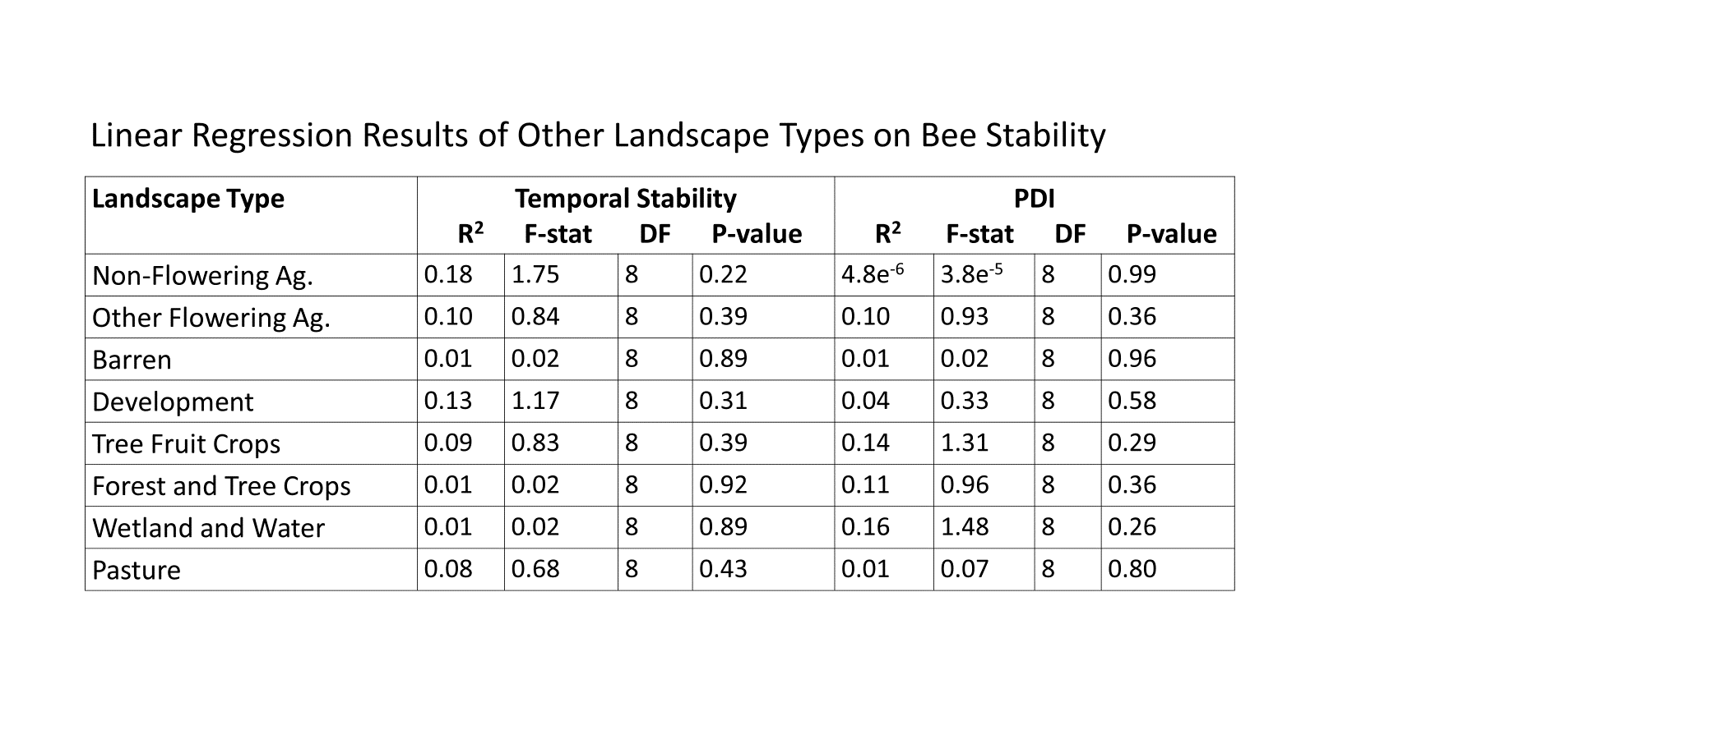

**Table 1.2.** Results of simple linear regression models of landscape cover types (area within a 2 km site radius) against bee temporal stability (TS) and percentage dissimilarity index (PDI).

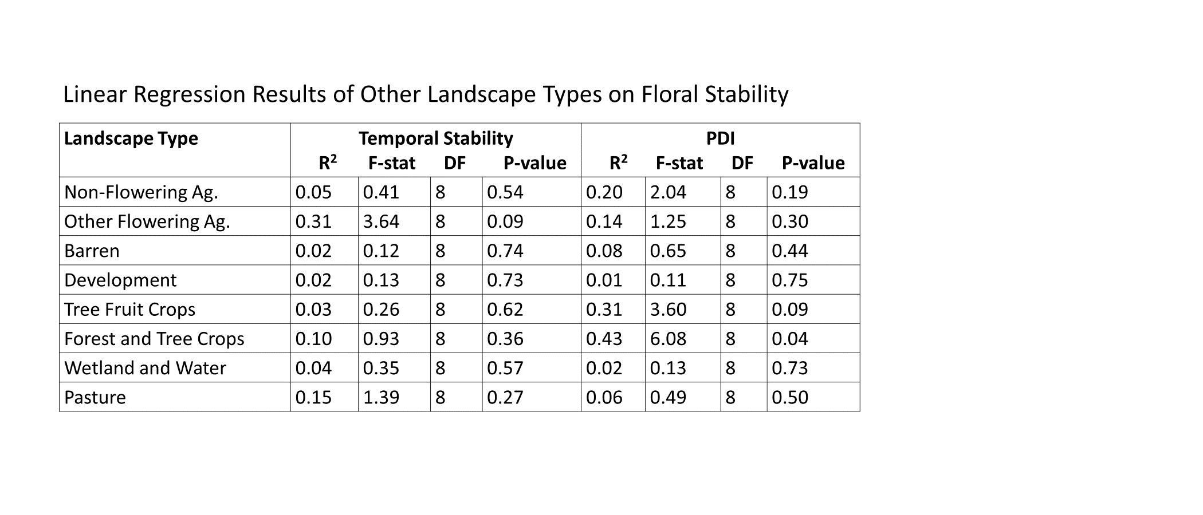

**Table 1.3.** Results of simple linear regression models of landscape cover types (area within a 2 km site radius) against floral temporal stability (TS) and percentage dissimilarity index (PDI).

**Table 1.4.** Results of simple linear regression models of landscape cover types (area within a 2 km site radius) against bee abundance, richness, and Shannon diversity values.

**Table 1.5.** Results of simple linear regression models of landscape cover types (2 km) against floral abundance, richness, and Shannon diversity values.

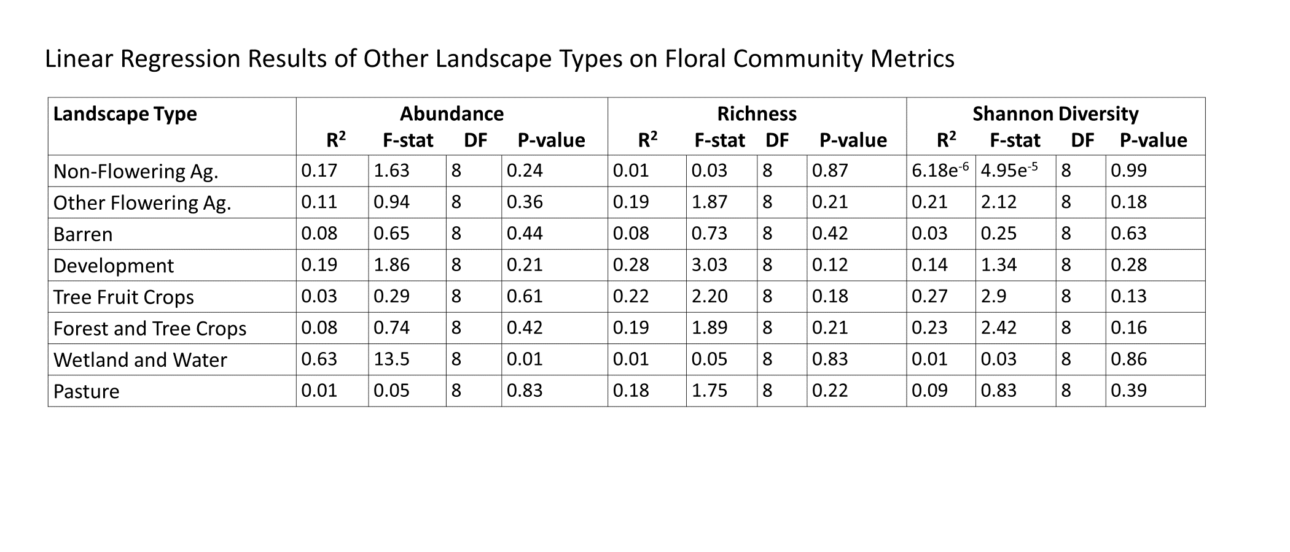

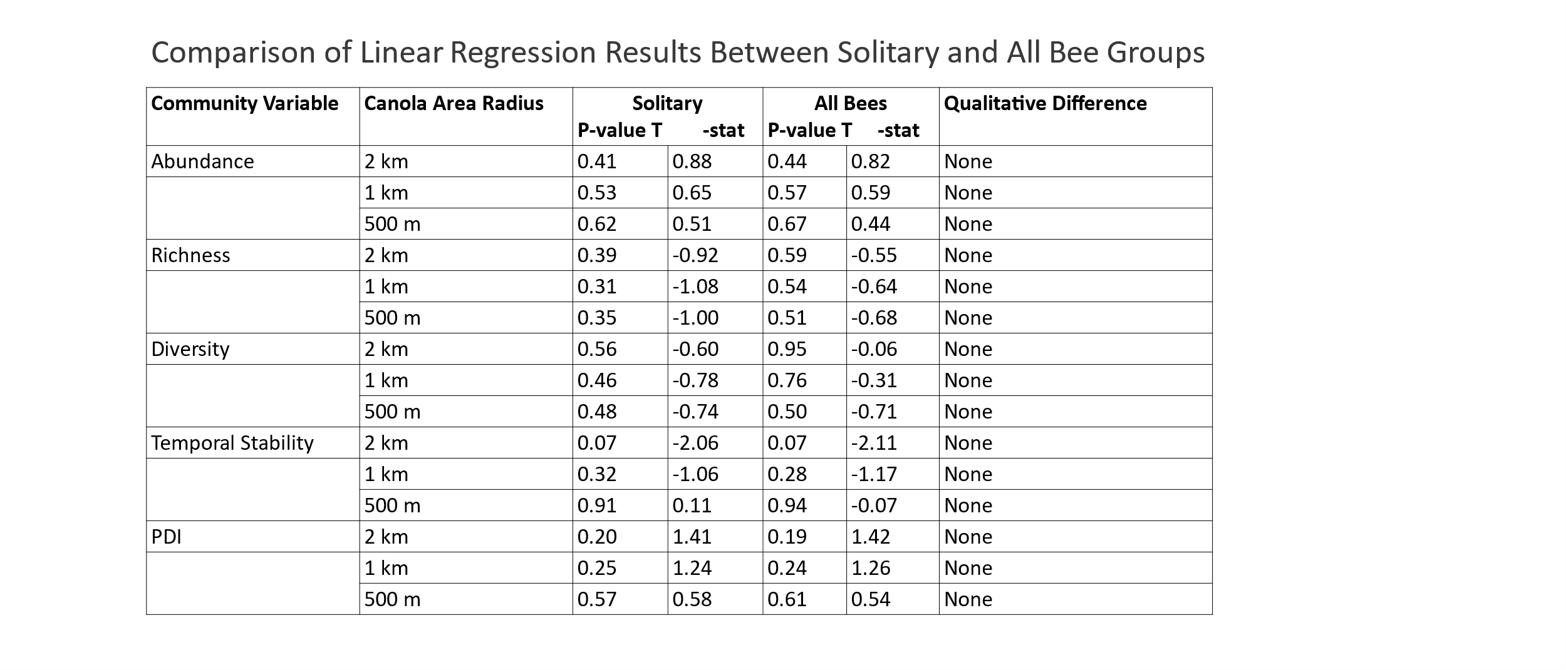

**Table 1.6.** Qualitative comparison of linear regression results fitting community and stability values to canola area in solitary bees and all bees.

**Figure Legends**

**Fig.1.1.** Map of field sites used for this study. Pink circles show a 2 km radius around each site. Canola fields in proximity to sites are defined in yellow. Note the variance in overlap between 2km radius circles and canola fields between sites.

**Fig. 1.2.** The number of bees overall within the three morphogroups. Letters represent significant difference between groups determined by Tukey HSD.

**Fig. 1.3.** Results of the Tukey HSD and one-way ANOVAs comparing plant and bee community values between seasons. Difference in color and letter demonstrate a significant difference between groups given by Tukey HSD tests. P-value of one-way ANOVAs are displayed.

**Fig. 1.4.** Results of Least Square Means and one-way ANOVAs comparing plant and bee community values between sites. Difference in color and letter demonstrate a significant difference between groups given by Least Square Mean tests. P-value of one-way ANOVAs are displayed.

**Fig. 1.5.** Results from Pearson’s correlation analyses of bee and plant diversity and stability metrics. Red boxes around estimate results indicate a significant correlation (P ≤ 0.05). Color indicates correlation estimate value. VA = temporal stability; Diversity = Shannon diversity.

**Fig. 1.6.** Simple linear regression results showing that floral abundance significantly increases with distance from canola fields. This is primarily driven by the Plaza site.

**Fig. 1.7.** Results of simple linear regression results comparing the effects of distance to canola and percentage of canola within a 2 km radius on bee temporal stability (TS) and percentage dissimilarity index (PDI)..

**Fig. 1.8.** Composition of bee morphogroups by site.

**Fig. 1.9.** Composition of bee morphogroups by season.

**Fig. 1.S1.** Bee Genera Composition at site Asotin.

**Fig. 1.S2.** Bee Genera Composition at site Chipman1.

**Fig. 1.S3.** Bee Genera Composition at site Chipman2.

**Fig. 1.S4.** Bee Genera Composition at site Clark1.

**Fig. 1.S5.** Bee Genera Composition at site Clark2.

**Fig. 1.S6.** Bee Genera Composition at site Spangle.

**Fig. 1.S7.** Bee Genera Composition at site Plaza.

**Fig. 1.S8.** Bee Genera Composition at site Hutchins.

**Fig. 1.S9.** Bee Genera Composition at site Smoot.

**Fig. 1.S10.** Bee Genera Composition at site Kamiak.

**Fig.1.1.** Field site map.

**Fig. 1.2.** Bee samples by morphogroup.

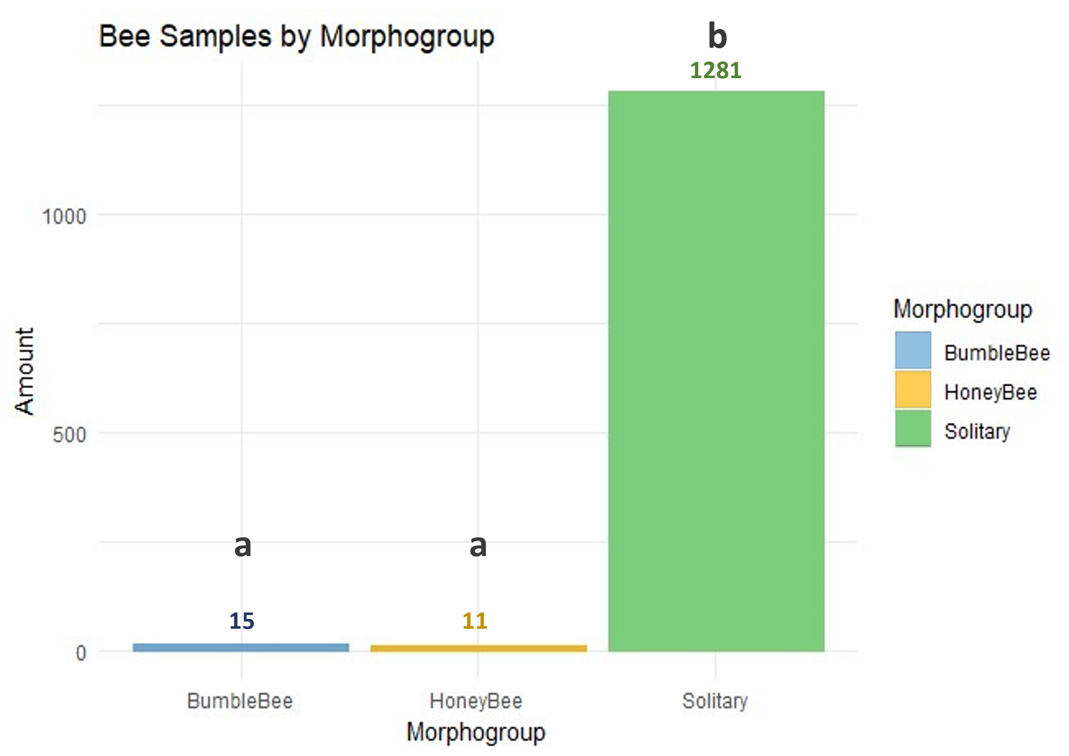

**Fig. 1.3.** Average community metrics by season.

**Fig. 1.4.** Average community metrics by site.

**Fig. 1.5.** Correlation of bee and plant community and stability metrics (TS = temporal stability).

**Fig. 1.6.** Linear relationship between floral abundance and distance to canola.

**(m)**

**Fig. 1.7.** Relationship between bee stability metrics and canola landscape context (TS = temporal stability).

**Fig. 1.8.** Composition of bee morphogroups by site.

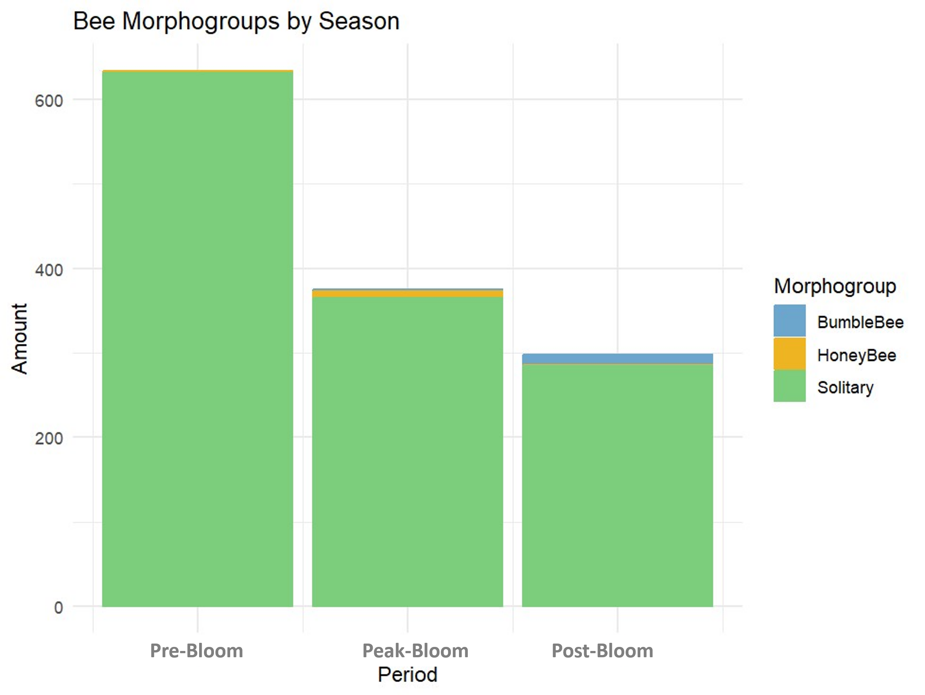**Fig. 1.9.** Composition of bee morphogroups by season.

Supplementary Figures**

**Fig. 1.S4.** Bee Genera Composition at site Clark1.

**Fig. 1.S2.** Bee Genera Composition at site Chipman1.

**Fig. 1.S1.** Bee Genera Composition at site Asotin.

**Fig. 1.S3.** Bee Genera Composition at site Chipman2.

**Fig. 1.S5.** Bee Genera Composition at site Clark2.

**Fig. 1.S6.** Bee Genera Composition at site Spangle.

**Fig. 1.S8.** Bee Genera Composition at site Hutchins.

**Fig. 1.S7.** Bee Genera Composition at site Plaza.

**Fig. 1.S10.** Bee Genera Composition at site

Kamiak.

**Fig. 1.S9.** Bee Genera Composition at site

Smoot.